Dear Parents/Carers,
I cannot believe that I am already writing to you to share the successes and stories of our first half term! I think that the cliché is that ‘time flies when you’re having fun’ but for me, personally, that is true! I have had a fabulous first half term here and it was with great pride that I took the opportunity to tell our prospective parents at Open Evening about the many, many strengths of this school.
It is clear to me that Lynch Hill students are focused, hardworking and well behaved but also fun, energised and keen to do so much more than just succeed in class. This was very evident on Open Evening, more of which can be read about elsewhere in this newsletter, where so many students gave up their time to act as car park attendants, guides, helpers in class and anything else that was required on the night! It was wonderful to see what a fantastic community Lynch Hill Enterprise Academy really is. I am particularly pleased at how well our Year 7’s have settled and it has been a pleasure to sit with them whenever I can at lunchtime and hear their enthusiastic chatter about their day!
Thank you to those of you who have supported events this term and those of you who have taken the time to give us feedback – it is greatly appreciated and I am always keen to hear more! I wish you a restful half-term break and look forward to welcoming the students back on Monday 29th October and hopefully many of you at future parents’ evenings and events.
Chris Thomas
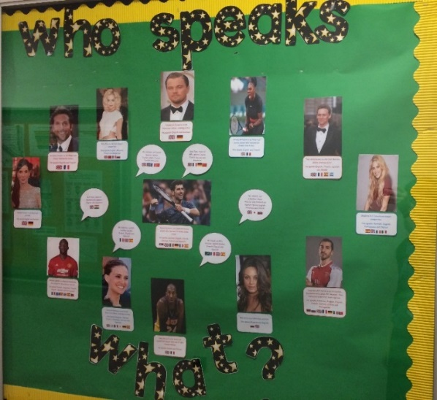
LHEA does the European Day of Languages
On Wednesday 26th September, the MFL department celebrated European Day of Languages. The idea was to recognise the diversity and the rich culture we have at Lynch Hill. It was a chance to acknowledge and celebrate all the home languages which our students and their families speak, as we have over 33 different communities in school. Staff were encouraged to allow students to answer the register in their home language and integrate languages into their lessons wherever possible! In MFL, we started off by updating our MFL display boards, showing off the language skills of famous celebrities, as well as the staff in school.
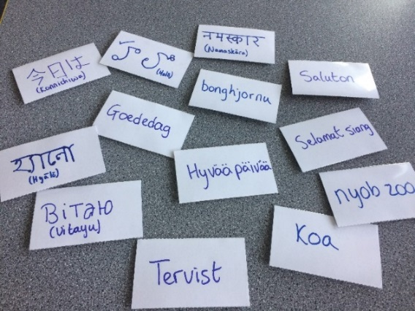
The highlight of the day however was the Languages competition which was held. All of the staff members wore badges with the word “hello” on it in different languages. We had over 50 different languages represented! The students had to go around and collect as many teachers’ names and their language as they could, as well as have a go at pronouncing the word. Our students got so involved, even telling off members of staff who weren’t wearing their “hello” badge! We had over 30 entries and it was a very tight competition! The eventual winner was Anthea in 7 Tesla, who collected 29 different ways of saying hello- a very impressive feat! She received her certificate and prize in assembly.
A big thank you from Team MFL for the support from the staff and students and congratulations to all students who took part! Achievement points have been awarded!
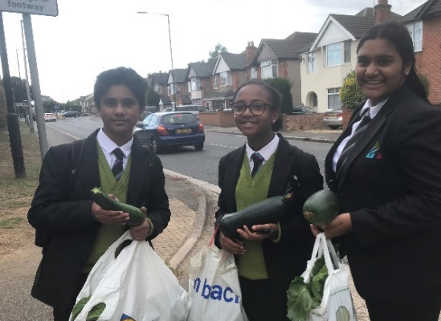
Horticulture Club Success
The team’s hard work last term paid off, and there was an excellent harvest. Here we see some of the group with their marrows.

Open Evening 2018
On Wednesday 3rd October, Lynch Hill Enterprise Academy opened its doors to the wider community and invited prospective parents and students to experience our amazing learning environment and to talk to staff and current students. The Head of School, Chris Thomas, delivered two presentations during the course of the evening which were well received and that highlighted the things that make LHEA such a special school including its community feel, wide-ranging curriculum offer, additional student support and exciting programme of extra-curricular activities.
Two students, Candice Arko in Year 7 and Avinash Jayachandar in Year 10, spoke about their experiences of life at LHEA and Ysabella Samarita in Year 8 sang a beautiful song to give a flavour of how students’ talents at LHEA are nurtured and developed.
Year 10 and 11 students led tours of the school throughout the evening with visitors commenting on how charming and professional they all were.
Many students from other year groups generously gave up their time to assist in subject areas. They enthusiastically talked with members of the public about their learning experiences as well as, for example, carrying out experiments in the science department, demonstrating their trampolining and basketball skills in the PE department and showing off their culinary skills. Students baked cakes and scones in the Food Technology department which were hungrily devoured by the visitors as they made their way round LHEA.
Chris Thomas, Head of School, thanked all of the students and staff for their efforts and contributions in making the Open Evening a wonderfully positive event:
“I have had some fantastic feedback from parents and we would look forward to welcoming their children to Year 7 in 2019. I also look forward to showing prospective parents around the school during our Open Morning Tour slots.”

Coming soon ….
LHEA’s very own ‘Cercle francais’ is being launched. This will be a monthly event where different topics will be discussed … in French. Students, staff and parents are invited to participate in this new French club. Please register your interest by sending an email to c.lepeltier@lhea.org.uk as soon as possible. Merci. Madame Lepeltier
MFL takes on National Poetry Day
On Thursday 4th October, the MFL department teamed up with the English department to work on poetry for National Poetry Day, on the theme of Change. Students in year 8 and 9 started by reading this poem by Samiuel about the changes which happen when autumn returns each year. They were then given the word “Changement” and had to write acrostic poems in French about change. The students found this quite challenging, as the French words had to fit into the word “changement” but they really rose to the occasion. They were using wonderful vocabulary, such as “couleur” (colour), “climat” (climate), “mot de passe” (password), “économie” (economy) and “enfance” (childhood), “hiver” (winter) and “nom” (name). Bethany, Insaf and Aleeza in year 8 and Charlie, Ellie and William in Year 9 produced particularly impressive poetry!

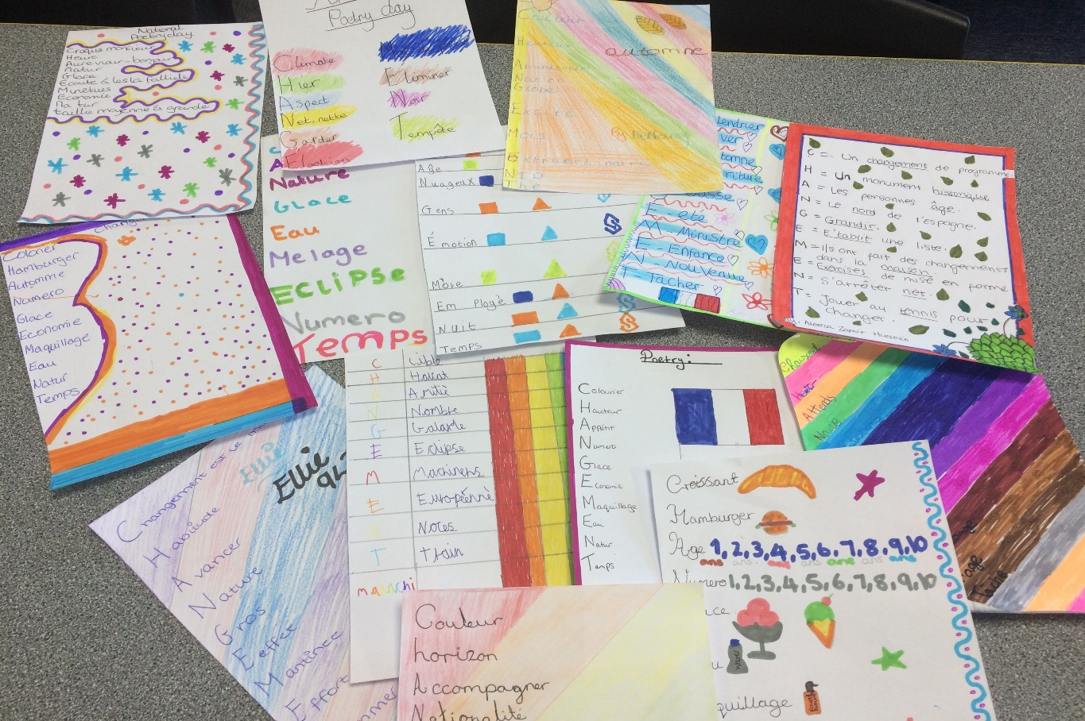

International Day of the Girl – 6th October.
LHEA celebrated International Day of The Girl on Saturday 6th October ahead of the official day on 11th October across the world.
A small group of Year 9 girls were given the opportunity to attend an event hosted by Upton Court Grammar School that provided resources for the group experiences and workshops to take place.
Being a United Nations sponsored event and under the theme, With Her: A Skilled GirlForce, International Day of the Girl marks the beginning of a year-long effort to bring together partners and stakeholders to advocate for, and draw attention and investments to, the most pressing needs and opportunities for girls to attain skills for employability.
Kyra Cochrane, LHEA’s representative said:
“One of the workshops I took part in was about the independence of the girl. We heard from eight women in an assembly how they made it through tough times in their lives and what inspirational people in their lives advised them to do to achieve their goals. They told us to always be ourselves and to follow your dreams because everyone can succeed if they never give up.
One fun activity was when we had to tangle ourselves up as one large group and then work together to untangle ourselves with the help of people you don’t know!
After lunch, I took part in a self-defence class. I learned how to defend myself if someone tries to grab me and how to be aware of your surroundings if you are alone at night.
After this, I joined a workshop that gave me advice on how to write a great CV. I learnt how to make it clear and easy to read and what kinds of achievements to include to impress people.
The last workshop was called “mix-up reality”. This was the best of all the activities because we used virtual reality technology to go around the world and we flew back in time to see the dinosaurs!
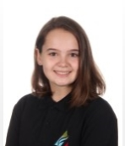
The last speakers were inspirational Sixth Formers. One girl told us about the experiences she had growing up and discrimination she received from society just because she is a girl. I really enjoyed the day and feel I learned a lot.”

Bicycle Safety – Journey to and from School

Riding is fun, healthy, and a great way to be independent. Nevertheless, it is important to remember that a bicycle is not a toy; it is a vehicle. Be cool – follow some basic safety tips when you ride.
Safe Riding Tips:
Before using your bicycle make sure it is ready to ride. You should always inspect your bike to make sure all parts are secure and working properly.
Always remember to:
- Wear a Properly Fitted Bicycle Helmet Protect your brain, save your life.
- Check Your Equipment Before riding, inflate tires properly and check that your brakes work.
- See and Be Seen Wherever possible, make yourself visible to others. Wear something that reflects light or attach flashing lights to your bicycle. Remember, just because you can see a driver does not mean the driver can see you.
- Control Your Bicycle Always ride with both hands on the handlebars. Carry books and other items in a bicycle carrier or backpack.
- Watch for and Avoid Road Hazards Be on the lookout for hazards such as potholes, pedestrians and animals. All these hazards can cause a crash. If you are riding with friends and you are in the lead, yell out and point to the hazard to alert the riders behind you.
When riding, always:
- Go With the Traffic Flow Ride on the left in the same direction as other vehicles. Go with the flow – not against it.
- Obey ALL Traffic Laws A bicycle is a vehicle. When you ride in the street, obey all traffic signs, signals, and lane markings.
- Yield to Traffic When Appropriate You must slow down and look to see if the way is clear before proceeding. This also means yielding to pedestrians who are using the pavement or crossings.
- Be Predictable Ride in a straight line, not in and out of cars. Signal your moves to others.
- Stay Alert at All Times Use your eyes AND ears. You need your ears to hear traffic and avoid dangerous situations; do not wear headphones when you ride.
- At School Dismount from your bike when you arrive at the school premise. Do not ride your bicycle anywhere on the school premises including the car park.
For anyone riding on the pavement:
  - Watch for vehicles coming out of or turning into driveways.
  - Always look and be aware of cars making sure the drivers see you before crossing.
  - Aware of pedestrians If others are using the pavement, ride at a sensible speed whereby both you and others around you will be safe.
  - Avoid pedestrians You can alert pedestrians that you are nearby politely saying, “Please excuse me” or “Passing on your left.”
  - Stick to your decision Cycle either on the pavement or on the road, not both.

Lynch Hill Enterprise Academy Student Counselling Service
Sometimes it can be hard to talk to friends and family about what you are going through and how this makes you feel.
Counselling is a way of exploring your innermost thoughts and feelings in a safe, supportive, non-judgemental and confidential environment with a trained professional.
From 30th October LHEA will be able to offer a limited counselling service to its students on a Tuesday, with Nicole Wilkinson.
Nicole is a BACP Accredited Counsellor with over 14 years counselling experience, specialising in working with young people. She will be helping them through many issues that they face from family troubles and relationships, depression, stress and anxiety to mention a few.
Nicole offers the students the space and time to help them make sense and cope with what difficulties they are having, within a safe, trusting and accepting relationship.

Counselling focuses on THE STUDENT:
- Listening to THE STUDENT
- How THE STUDENT is feeling
- What is affecting THE STUDENT
Counselling does not give them the solutions, but empowers them to grow, develop and change
The service will be confidential (within normal Safeguarding Guidelines) and open to all students. If you would not like your child to be able to access this service without your permission, please email a member of the SLT to discuss it and let them know. However, parents will be contacted prior to a student starting counselling if LHEA feel that is appropriate to seek parental permission explicitly.
Full details of the service can be found on the school website.
sQuid cashless payment system
All students have been issued with registration letters and should have registered online by now, therefore the canteen in no longer accepting cash. Should a replacement registration letter be required, one can be obtained from reception during break or lunchtime. Please make sure that there is money available for the students to access by topping up sQuid regularly. Thank you.

Second-hand uniform
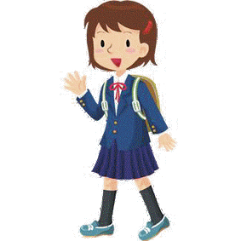
A small amount of second-hand uniform is available from the school. Please contact Mrs. Flegg through the office if you are interested.
Head’s coffee morning/afternoon tea!
This is an invitation to come in for a drink and informal chat with me, as the new Head of School here at Lynch Hill Enterprise Academy. I am interested in hearing your views about the school and exploring ways in which we can work more closely to support our young people. There are 3 time slots available so I hope that you will be able to find one which suits you. Please call the school or email on office@lhea.org.uk if you would like to attend.
Dates:
Tuesday 6th November 4-5.30pm
Wednesday 7th November 2-3.30pm
Thursday 8th November 9-10.30am

Achievements and behaviour
We have had a very positive start to the new school year with students regularly being awarded with achievement points for their active contributions to lessons and golden tickets in recognition of their good citizenship and excellent manners.
Manifestos have been written and elections held for the year council representatives for every year group. Each Year Council has led its first event: a cake sale, which proved to be very popular and revealed some talented bakers. Along with our Mufti Day, I am delighted to announce that these events have raised an impressive £757.73 for an extremely worthy charity: MacMillan Cancer Support.
The school has also taken part in the Make your Mark ballot which gives a voice to young people enabling them to vote on the issues that concern them. The top 3 issues that our students voted for are to: 1) Put an end to knife crime, 2) Have a curriculum to prepare us for life, 3) Let’s tackle homelessness. This ballot then helps decide what Members of the UK Youth Parliament should debate and vote on in their campaign for 2019.

Our half termly awards have been given and the recipients are as follows:
Highest conduct points – Achievement points minus any behaviour points:
Year 7 - Beverley Osei-Owusu
Year 8 - Harshini Suseevan
Year 9 - Habeeb Abdul Khader
Year 10 - Kaylee Decelis
Year 11 - Gurvinder Virdee

Tutor groups with the highest attendance
7 Jobs
8 Tesla
9 Turing
10 Einstein
11 Ramanujan

Key stage students of the half term – awarded by the Head of Year for outstanding contribution to school life:
Year 7 - Antonella Queirolo
Year 8 - Aadam Khan
Year 9 - Kyra Cochrane
Year 10 - Moeid Dar
Year 11 – Hamza
Golden ticket draw winners – for good citizenship
David Szymkowiak
Leena Hassan
Tafara Oguntoye
Antonella Queirolo

Student Council representatives
7 Curie — Millie Honey & Abdel Arcot
7 Da Vinci — Isaac Towne & Jessica Smith
7 Einstein — Khadiqa Sharif & Fareed Saruk
7 Jobs — Hashim Ibrahim & Hamzah Iqbal
7 Tesla — Antonella Queirolo & Royce Rameshkumar
7 Turing — Candice Arko & Tanaya Carty-Adewuyi

8 Curie — Deena Patel & Aaron Jones-Fadayomi
8 Da Vinci — Awatif Wadi & Feisal Abu
8 Einstein — Chloe Porter & Insaf Slim
8 Jobs — Isabella Mensah & Ali-Abrar Arshidh-Ali
8 Tesla — Victor Zyla & Vansh Sood
8 Turing — Wendy Frempong & Oliwer Pawlik

9 Galileo - Zeeshan Anaz & Sami Naseem
9 Jobs - Micah Marata & Shahan Jumshaid
9 Tesla - Kyra Cochrane & Ilham Mohamed
9 Turing - Rachael Adegbola & Yasir Ibrahim

10 Curie - Ameen Rehman/ Tauheed Ibrahim & Amber Banks
10 Da Vinci - Moeid Dar & Safah Ayaz
10 Einstein - Avinash Jayachandar & Hewad Hanifi

11 Al-Haytham - Kenza Oukriss & Jerome Lye
11 Jackson - Ballaj Khan & Madinah Dsane
11 Ramanujan - Klaudia Ciesnowska & Umar Khan

Important Dates…
Half Term Holiday: Mon15th to Fri 26th Oct
Year 10 Parents Evening: Thurs 22nd Nov 4-7pm
Year 11 Parents’ Surgery: Wed 28th Nov 09:15-10:30
Year 7 Tutor Evening: Thurs 29th Nov 4:00-6:00
Year 10 Parents’ Surgery: Wed 5th Dec 09:15-10:30
End of term: Wed 19th Dec 1pm

